A Project-I Report on
Windows Application for Pharmacy Management System
Submitted in Partial Fulfillment of the Requirements for
the Degree of Bachelor Of Engineering in Computer engineering
under Pokhara University

Submitted by:
Bikash Singh, 15371
Damber Upadhyay, 15387
Pravin Gautam, 15365

Under the supervision of
Dr. Roshan Chitrakar

Date:
Jan 29, 2017




Department of Computer Engineering
NEPAL COLLEGE OF INFORMATION
TECHNOLOGY
Balkumari, Lalitpur, Nepal.
ACKNOWLEDGEMENT

We are pleased to acknowledge Dr. Roshan Chitrakar for his valuable guidelines to the team throughout the entire project time. He aided especially in the documentation phase, without which the completion of this project would be an uphill task.
We extend our sincere thanks to Mr. Dilendra Bhatt and Er. Shiva Hari Acharya whose suggestions and recommendations were extremely useful in figuring out the limitations of our application and making the application more user friendly.
We are also grateful to all our teachers, classmates and the college administration who directly or indirectly cooperated with us in making this project successful.

Bikash Singh (15371)
Damber Upadhyay (15387)
Pravin Gautam (15365)
Nepal College of Information Technology
Balkumari, Lalitpur.

January 2018

ABSTRACT

Pharmacy management system is a windows application which aims in the management of the database of the pharmaceutical store. This program can be used in any pharmaceutical store having a database to maintain. This project has many features like facility of stock management, data search and medicine details. The feature of search provides searching any similar data in database. The software used can generate reports, as per the user’s requirements. The software can print purchase-sell receipt. It can also maintain the record of supplies sent in by the supplier/company. The use of material design lifts the visuals of the application making the application look simple and intuitive. Visual Studio is used for development and functionality and visual basic language is used for programming. Overall this project of ours is being developed to help the pharmaceutical owner to easily store information about medicine, purchase-sell information and stock information.

Table of Contents
1. INTRODUCTION .............................................................................................................. 1
1.1. Problem Statement ................................................................................................................................. 1
1.2. Project Overview .................................................................................................................................... 1
1.3. Project Objectives .................................................................................................................................. 2
1.4. Project Scope and Limitation ................................................................................................................. 3
1.5. Significance of the Study ........................................................................................................................ 3
2. METHODOLOGY ............................................................................................................. 4
2.1. Concept Design ...................................................................................................................................... 4
2.2. Development .......................................................................................................................................... 5
2.3. Packaging................................................................................................................................................ 5
3. Literature Review/ Study .................................................................................................... ..8
3.1. Windows ................................................................................................................................................. 8
3.2. Application .............................................................................................................................................. 8
3.3 Visual Basic Language............................................................................................................................ 9
3.4. Database……......................................................................................................................................... ...10
4. Project Members and Works............................................................................................ .11
5. Requirements .................................................................................................................... ..12
6. Conclusion ........................................................................................................................ ..13
7. Further Extensions ............................................................................................................ ..14
8. Bibliography ..................................................................................................................... ..15
9. Appendix .......................................................................................................................... 16
Figures

Figure 1 Concept Design ........................................................................................................................ 4
Figure 2 Kitabbazaar Homepage............................................................................................................. 4
Figure 3 Wordpress ................................................................................................................................. 5
Figure 4 Classeria- WordPress Theme.................................................................................................... 5
Figure 5 WordPress Plugin ..................................................................................................................... 6
Figure 6 ErSathi Technology Website .................................................................................................... 6
Figure 7 Kitabbazaar Logo ..................................................................................................................... 7
Figure 8 Database Concept ..................................................................................................................... 9
Figure 9 Ecommerce ............................................................................................................................. 10
1. INTRODUCTION

Pharmacy management system application is a simple windows application which stores information about pharmaceutical store. This application runs in windows operating system Windows 7 and above.

Pharmacy management system is a foreground application which is more accessible by the user. The user interface called first activity holds the major functionality of the application. The clear cut services menu like supplier/company information, pharmacy information and search menu quickly gives the user their required medicines which is handier to use. The search menu easily shows the data list/record to the user. In pharmacy record, user can add new info of sold medicine to list, delete old info of sold medicine from list and can edit information about info of sold medicine. In company record, user can add new info of purchased medicine to stock, delete old info of purchased medicine from stock and can edit information about info of purchased medicine. They can add new medicine available in the store to list. User can manage the stocks of medicine so that whenever some medicine is not available in the store, they can easily know which medicine is unavailable.

1.1. Problem Statement
This application is designed because of these problems. The details of problem statements are presented below
- Searching of old customer data/list can create more problems.
- Multiple numbers of medicine creates confusion to the user.
- Tracking of pharmacy database manually is difficult.
- Lack of good pharmacy management application.
- Available application being either too complicated or lacking key features

1.2. Project Overview
Management System is an easy way for storing data in an era of science and technology. Nowdays in every field , there is use of technology. Thus in field of managing information, management system are popular. Hence, we have been trying to create an application ‘Pharmacy Management System’ so that managing the customer information and medicine information in pharmacy should be easier and effective.

1.3. Project Objectives
This application is designed to maintain pharmacy data easily. The major objectives of the project are as follows:
- To process, track, and dispense all prescriptions with the higher level of security.
This software ensures high level security of the pharmacy data because of use of database for storing data.

- To process, track, and dispense all prescriptions with the higher level of accuracy.
User of this software can also search information from stock accurately.

- To process, track, and dispense all prescriptions with the higher level of efficiency.
By using this software user can also store information about pharmacy or provider efficiently. It store information in such a way that consumes lowest amount of memory.

- To provide simple and attractive user interface.
Use of the material design makes the app simpler to use. To use this app user does not require more specific knowledge. User having simple knowledge can easily use its features.

- To remind about pharmacy inventory.
This software helps to remind the user/pharmacy owner about pharmacy inventory and out of stock items. This reduces the confusion to the user.

1.4. Project Scope and Limitation
This application/project benefits only those users who has pharmacy or medicine store. So it won't be any use for the normal people. Another use of this application is to search for medicine so this feature is also not useful for all the common users. This application requires windows device/computers having window 7 and above users so it can't provide service for rest. Software requires its minimum storage for installation. This application is not supported in android, PC Mac, Linux etc.

1.5. Significance of the Study
The study investigates the need of management system application in many fields. This project is based on data management system for pharmacy. This application can be easily used by pharmacy owner for managing data about customer and medicine purchasing and selling. System user can easily edit and review their inputted data about pharmacy using this software. The framework we have been used is .net framework theme under XML, SQL, visual basic and JavaScript language.

2. METHODOLOGY

The proposed methodology is categorized into Design portion, Development portion, Packaging, distribution and update. These methods are divided to developers for the better and fast completion of the project.
2.1. Concept Design
The design parts consists of sample layout design of the main activity (first activity) and other activity/pages. The sample designing consists of logo design, icon design, services icon design and layout design of the application.
2.2. Development
Our development part will be completed using the following methodology;
- Using Visual Studio for writing and compiling.
- Using Visual Basic language for coding.
- Using Windows based PC to run and test the application.
- The application is made for Windows 7 and above.
- Use of material design for the interface of the program
- The simplified application of the application is given below.
- Simple user interface of the application.
- Three segments of the application
1. Company Record
2. Pharmacy Record
3. Search from stock
We used Microsoft Visual Studio for making the software .

2.3. Packaging

Visual Basic provides an easy way for you to deploy your custom My namespace extensions by using Visual Studio templates. If you are creating a project template for which your My extensions are an integral part of the new project type, you can just include your custom My extension code with the project when you export the template.

3. Literature Review/ Study

This section consists of the literature study in different topic like Windows, Application, and Visual Basic language for application development.

3.1. Windows
Windows, is a group of several graphical operating system families, all of which are developed, marketed, and sold by Microsoft. It is mainly designed for Computers and Windows Phones. Windows is also found in wide range of hardware's like ATMs, Xbox one, cars etc. Microsoft introduced an operating environment named Windows on November 20, 1985, as a graphical operating system shell for MS-DOS in response to the growing interest in graphical user interfaces (GUIs).

3.2. Apps (Application)
Apps are software programs that are executed in a computer, smartphone or other device. The most common use for the term app is to denominate software programs that run on smartphones or mobile devices.
In Windows, Apps contain compiled Java code, data files and resources files used by each app. All of this comes packed up in a file denominated Windows Application Package, with extension .exe.

3.3. Visual Basic Language
Visual Basic is a third-generation event-driven programming language and integrated development environment (IDE) from Microsoft for its Component Object Model (COM) programming model first released in 1991 and declared legacy during 2008. Microsoft intended Visual Basic to be relatively easy to learn and use. Visual Basic was derived from BASIC, a user-friendly programming language designed for beginners, and it enables the rapid application development (RAD) of graphical user interface (GUI) applications, access to databases using Data Access Objects, Remote Data Objects, or ActiveX Data Objects, and creation of ActiveX controls and objects.

3.4. Database
Database is a collection of information that is organized so that it can be easily accessed, managed and update. Visual Studio uses MySQL management system. MySQL is a software used to create databases, store and get data when requested.

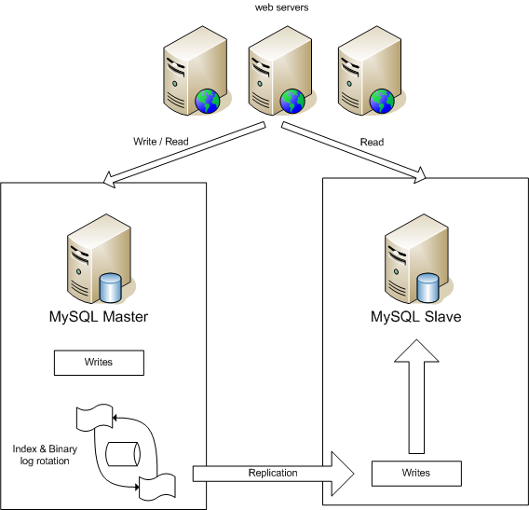

Figure 8 Database Concept

4. Project Members and Works
Name | Roles | Responsibilities
Damber Upadhyay | • Concept design  • Logo design  • User testing | • Design portion  • App testing
Bikash Singh | • Documentation  • Coding  • Project management | • Documentation of  proposal and report  • Resource collection  • Financial support
Pravin Gautam | • Coding  • Layout design  • Application controls | • Application design  • Application coding

We have divided our project based on project members

5. Requirements
Application requirements are a list of necessary functions, capabilities, or characteristics related to our application and the plans for creating it. There are several types of requirements that may be defined during the process that come together to focus and prioritize the project plan.
- System availability
- Allowance for maintainability and enhancements
- Recovery from failure
- Reliability
- Response time
- Throughput
- Order management and communication
- Order verification, confirmation, and fulfillment
- Preparation, distribution, and inventory control, storage, and security
- Administration
- Intervention and monitoring

6. Conclusion
Finally we came to conclusion from this project, pharmacy owners find the way to buy and sell the medicines with proper data management. Also we had provided the print feature for printing receipt. It’s the management purpose application. The users will get the service from this application according to their needs and our terms and conditions.

7. Further Extensions
Application will be regularly updated according to our terms and conditions. We will try to add other features in future to improve the application per users requirement. The basic update to be performed in regular basis is:
• Feature update
• Functional updates
• Version update

8. Bibliography
- Evangelos peroutsos: - Mastering Visual Basic 6.0.

- Greg Perry, Sanjaya Hettihewa: - Visual Studio 6.0 in 24 hours.

- Wikipedia

- Google

9. Appendix
1. Home page
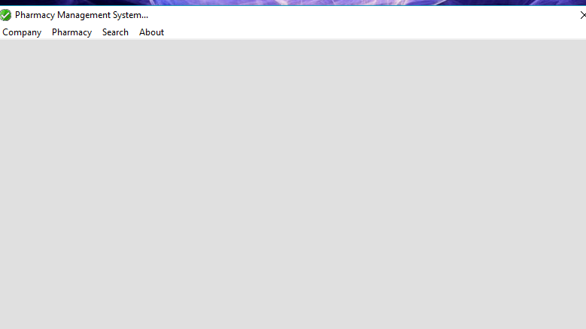

2. Company Record

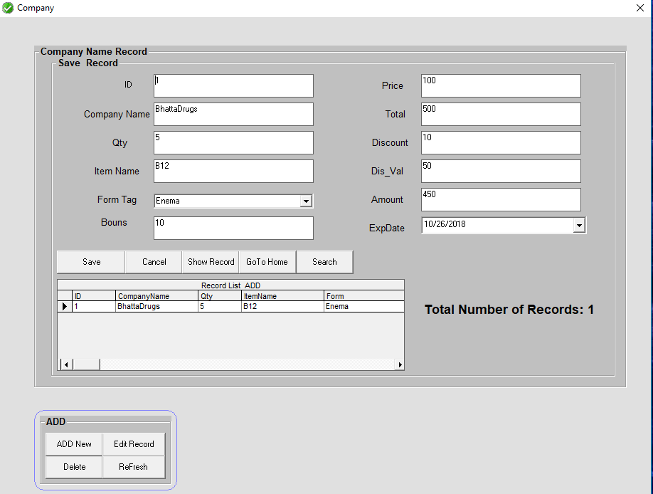

3. Company Stock Record

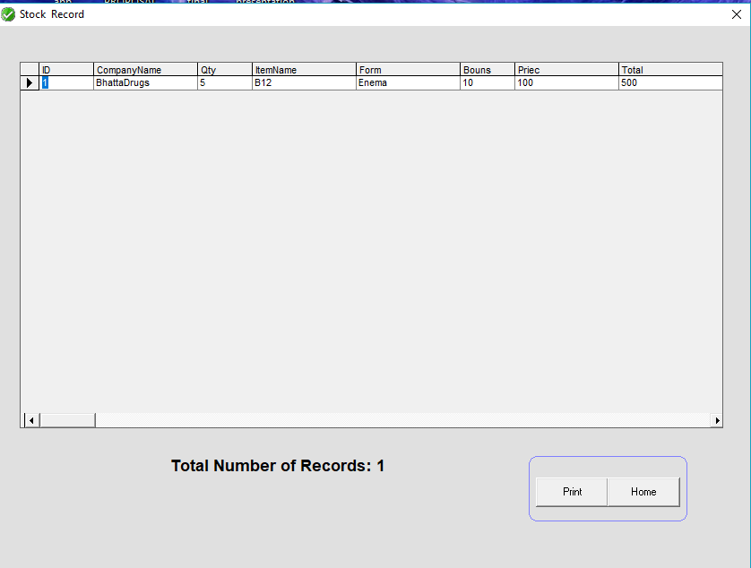

4. Pharmacy Record

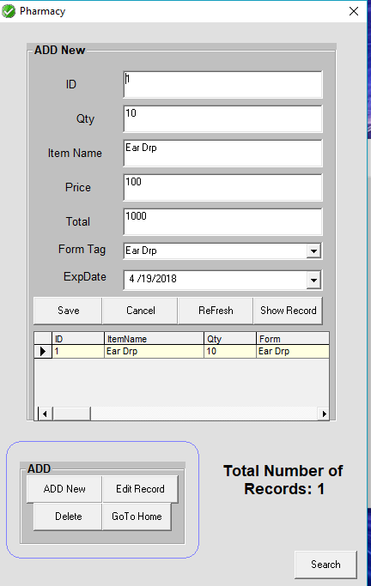

5. Pharmacy Stock Record

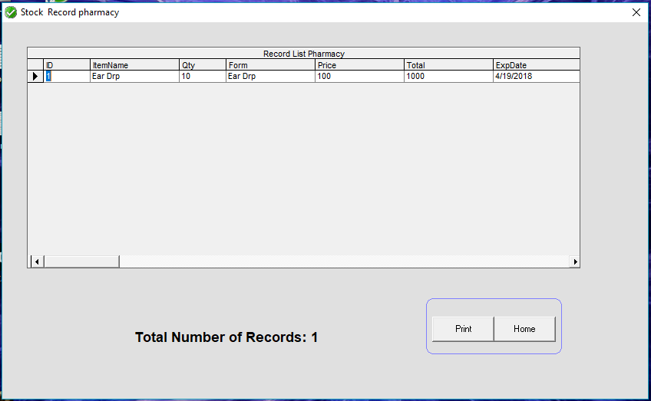

- Search Company Record

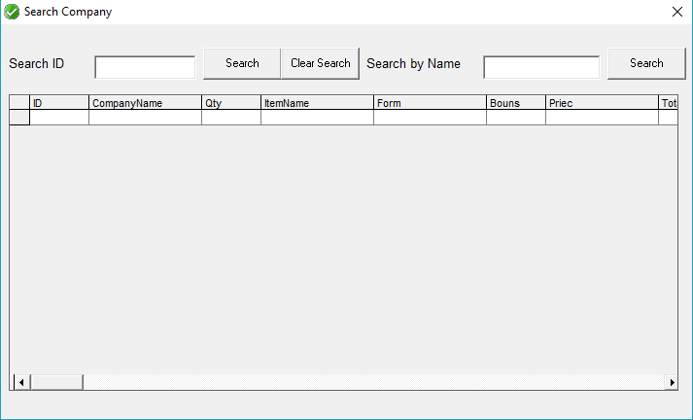

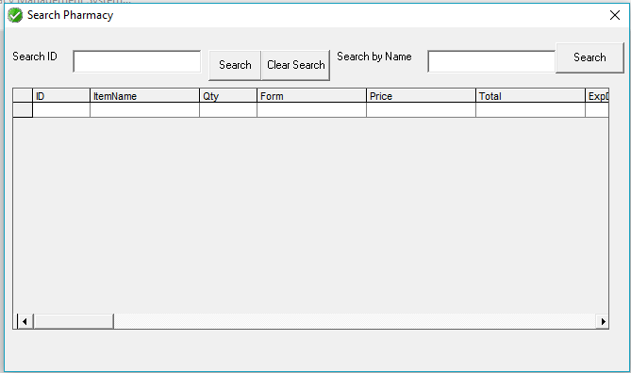

- Search Pharmacy Record

